Learning analytics (0,5)
Along with technology improvements, every aspect of life is being transformed. We are witnessing huge digitalization everywhere whereby vast amounts of data are being collected. Learning is no exception [1] as learners engage in “anytime, anywhere any device” learning consequently generating a lot of log data [2], [4], [5]. Siemens (2010) defines Learning Analytics as “the use of intelligent data, learner-produced data, and analysis models to discover information and social connections, and to predict and advise on learning.” [1]. Learning analytics consider collection, measurement, analysis and reporting of data about learners with the final goal of better understanding learning and enhancing learning efficiency.
In one amongst a vast array of studies students are taking virtual lessons in Yuan Ze University, whereby logs of data are being recorded, parsed and analysed using intelligent algorithms and then displayed in human readable format (usually graphs and tables). Results of learning analytics give better insight for teachers in form of student profiles [6]. By creating a profile for each student and by comparing data of similar students, systems can give feedback about lessons took, suggest next steps in learning or predict learning progress.

Prediction algorithms (0,5)
Following the log data collection, a learning analytics system tries to extract important information from the data. The field of computer science dealing with extracting important information from datasets is called machine learning. Machine learning algorithms use diverse approaches to analyzing the data using algorithms made of three parts: the model, loss function, and the optimizing method. In the model, (not necessarily finite) solution set is to be searched for the one that has the smallest loss using specified optimizing algorithm. In case where there of success data throughout time, learning curve could be predicted. The problem of predicting learning curve is equivalent to interpolation between points or finding the function that is the best approximation of the points in time trend. Regression is arguably the best known algorithm that finds which function from the function space best approximates the points [7], [8].
Data collection via logs and log processing algorithms (1)
In this study the students have taken three different type of lessons: gamified, augmented reality and collaborative lessons. In each of this types, there are different groups of learning exercises and each of these has a different type of logging. Logs are stored in a database as a single row with attributes with the information about students, date and time of a log and a description of the characteristic of the lesson. Images img1, img2 and img3 depict the structure of such objects for each of type of the logs.
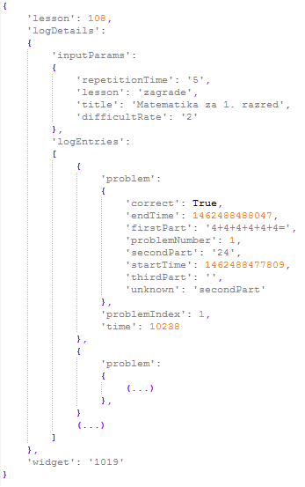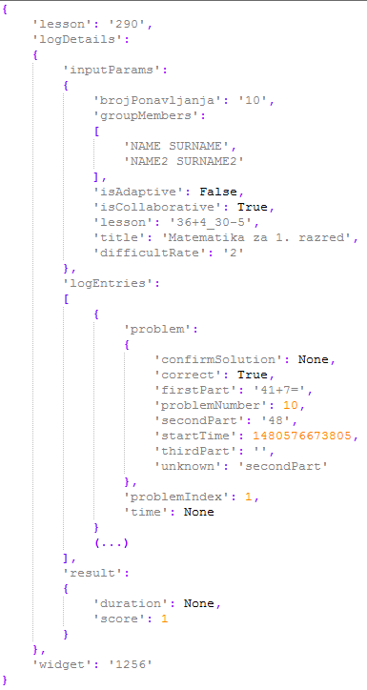
img1 competitive loges img 2 colaborative lesson log
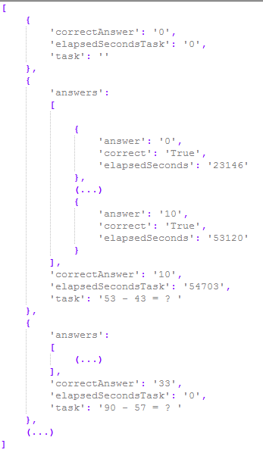
img 3 AR lesson log

Amongst other data, all the logs who information about whether a student solved exercise correctly and the recorded solution time.
Student learning success and task difficulty computation algorithms (1)
Calculating student success is always a difficult task in case when there is no prior information if lessons differ in difficulty and especially if all students did not take the same set of lessons. The difficulty coefficient of a lessons could be extracted from data only if the same set of students attempt to solve them (i.e. lessons that have been solved two times more successfully than some other lessons are two times easier). The Same thing can be said for extracting student success in lessons if all took same lessons. If there were information available about differences in terms of difficulty between lessons it would be possible to calculate students’ success coefficient. Analogously, if there were information about the efficacy of students (so we could mathematically compare students’ efficacy), lessons difficulties could be calculated.
The above mentioned recursive dependency can be written as follows:
$$S=f\left(L\right)$$
$$L=f\left(S\right)$$
S – Students’ success (vector)
L – Lessons’ difficulties (vector)
Student success is rated with a real number from [0, 1], where 1 means 100% success and 0 means 0% of success. Lesson difficulty is also rated with a real number from [0, 1] where 0 means 0% of average successful students successfully completed and 1 means 100% of average successful students successfully manage to complete. Average difficult lessons will be weighted with 0.5. Information on whether a student at index i solved lesson j is stored in a matrix at position T(i, j) with values:
$$T_{i,j}=T(i, j)=\left\{\begin{aligned}-1, & student i falied j lesson \\ 0, &student i {didn}^{'}t attempt lesson j \\ 1, &student i solved lesson j \\ \end{aligned}\right.$$
Accuracy and time of solving an exercise in a lesson j for student i is stored in a matrix at position P(i, j) with a real number ranging from [0, 1], where 1 is the best accuracy and time. P(i, j) is a function of time and accuracy which differ from lesson to lesson. For P(i, j) the following formula is used
$$P_{i,j}=P\left(i, j\right)=1-\frac{\min\left(t_{max},\max\left(0, t-t_{min}+f*(n-1)\right)\right)}{t_{max}}$$
Where t, tmin, tma, f and n are:
$t-time for solving the exercise$,
$$t_{min}-expected time to solve the exercise,$$
$$t_{max}-expected maximum time to solve the exercise,$$
$$f-penalty factor,$$
$$n-number of attempts$$
The formula has the following properties:
- P(i, j) = 1 if it took student less than t_{min} time to solve the exercise and he/she solved it in first attempt.
- P(i, j) = 0 if it took student more than t_{max} time to solve the exercise.
- P(i^{(k)}, j^{(k)}) > P(i^{(l)}, j^{(l)}) if student k had less attempts than student l and in same time as the student l.
t_{min},t_{max} and f are lesson-specific and should be wisely chosen (i.e. t_{min} could be the time in witch at least 60% of students solved the problem t_{max} is two times t_{min} , while f equals 2 seconds).
Following the above, recursive formulas for a student’s success S and a lesson’s difficulty L, respectively, are:
Oi=j=1mfsaTi,jftTi,jfpLi,jTi,j* Pi,jj=1mfasTi,jfpLi,jTi,j* Pi,j
Lj=i=1nfasTi,jftTi,jfpOiTi,j* Pi,ji=1nfasTi,jfpOiTi,j* Pi,j
where
m is the number of lessons (size of L),
n is the number of students (size of S), and
fasx=x2
is function which returns 1 if a student attempted to solve the lesson and otherwise 0, and
$$f_{t}\left(x\right)=\frac{x+1}{2}$$
is function that returns 1 if a student correctly solved and 0 if otherwise, and
$$f_{p}\left(x\right)=k^{1-2x}$$
is the projection function that has following properties:
- $f{\left(0\right)}^{T_{i,j}}$ = k, (student i gets k points for solving the hardest exercise j, but loses $\frac{1}{k}$ points for failing)
- $f{\left(0.5\right)}^{T_{i,j}}$= 1, (student i gets 1 point for solving an average (weight is 0.5) exercise j, but loses 1 for failing)
- $f{\left(1\right)}^{T_{i,j}}$= $\frac{1}{k}$, (student i gets $\frac{1}{k}$ point for solving the easiest exercise j, but loses k for failing)

In order to find a solution to this problem an iterative approach by first fixing S and calculating O, then fixing O and calculating S, and repeating the procedure until S and O converge is used. Experimentally, the proof has been made that this problem always converges but not always to same values, whereby they depend on initial values of O and S. This was expected (i.e. if all students solved all lessons, it could mean all students know the lessons or lessons are too easy, or even both). To solve this non-deterministic problem, the initial values of S will be set to 0.8 and of O to 0.5 (an assumption is being made that students are more likely to be successful then that problems are easy). With that assumption the system will mistake rather mistake by showing better success for a student then by showing worse success.

Prediction algorithms (1)
Once periodical data with information on students’ success are available, one can assume that it can be used for future prediction of the same type of data. The assumption is correct only when difficulties of lessons do not change over time. The data needs to be preprocessed and lesson difficulties need to calculated, fixed and the success of students need to be calculated. Machine learning algorithm based on regression with its model being in the family of logarithmic functions is used. Loss function of the algorithm is a square loss (L2 loss), and the optimizing method is the gradient descent method.

[1] http://ifets.info/journals/15_3/4.pdf

[2] http://ieeexplore.ieee.org/document/6982089/

Big Log Analysis for E-Learning Ecosystem

[3] http://www.jstor.org/stable/pdf/jeductechsoci.15.3.58.pdf

[4] L. Breslow, D. E. Pritchard, J. DeBoer, G. S. Stump, A. D. Ho, and D. T. Seaton. " Studying learning in the worldwide classroom: Research into edXs first MOOC, " Research & Practice in Assessment, vol.8, 2013, pp: 13-25.
[5] T. KARSENTI, " What the research says, " International Journal of Technologies in Higher Education, vol.10(2), 2013, pp. 23-37

[6] http://ieeexplore.ieee.org/stamp/stamp.jsp?arnumber=7335629
Open Student Models of Core Competencies
at the Curriculum Level: Using Learning
Analytics for Student Reflection
[7] Introduction to Machine Learning - Ethem Alpaydin
[8] STRUCE_Bishop_-_Pattern_Recognition_and_Machine_Learning

For learning curve prediction:
http://www.aclweb.org/anthology/P12-1003
http://ac.els-cdn.com/S1877042814021338/1-s2.0-S1877042814021338-main.pdf?_tid=5388cb4e-44a5-11e7-9fa7-00000aacb360&acdnat=1496086432_7856d0e3edad5bbf449f8bc6c9011c76

http://www.sciencedirect.com/science/article/pii/S016981411100062X

